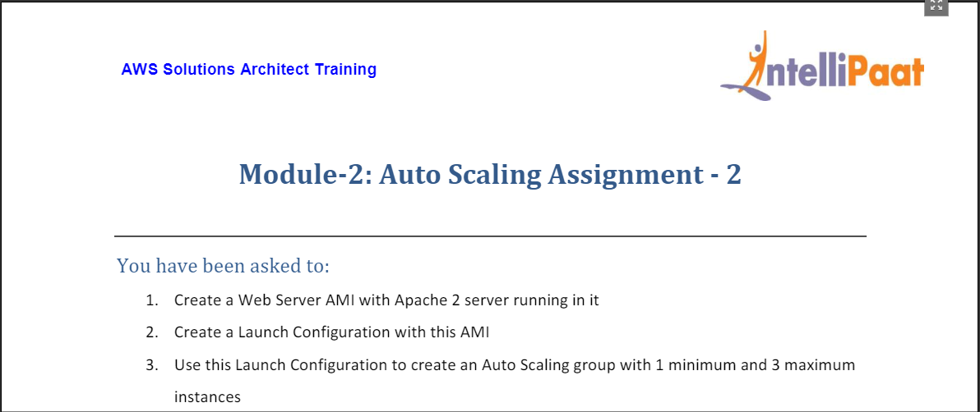

* Created a Webserver with Apache 2 running in it. (IP is 3.94.110.22)

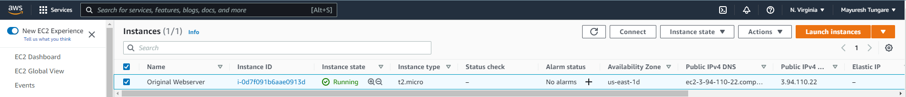

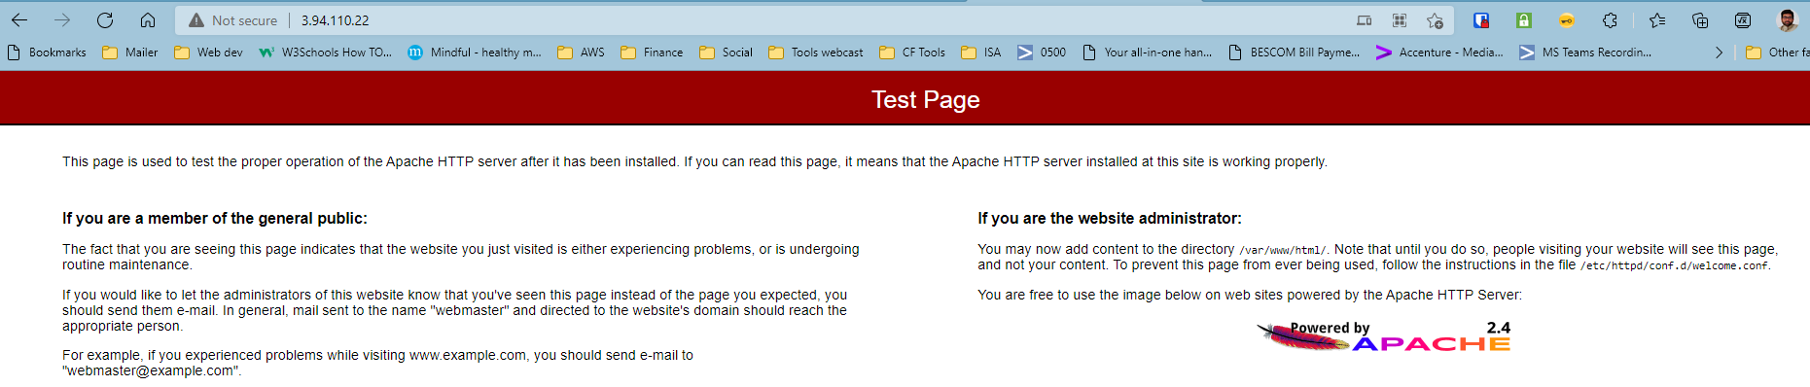

* Created an AMI of the Webserver

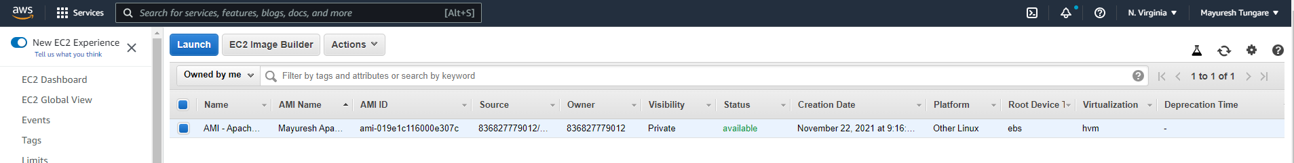

* Created Classic Load Balancer

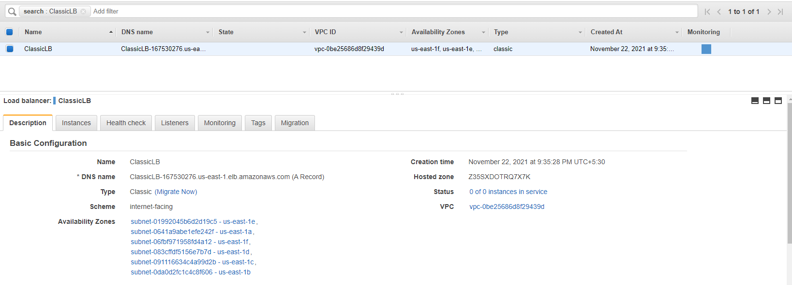

* Created Launch Configuration

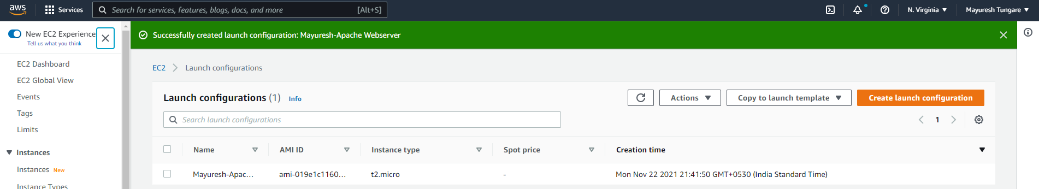

* Created AutoScaling Group

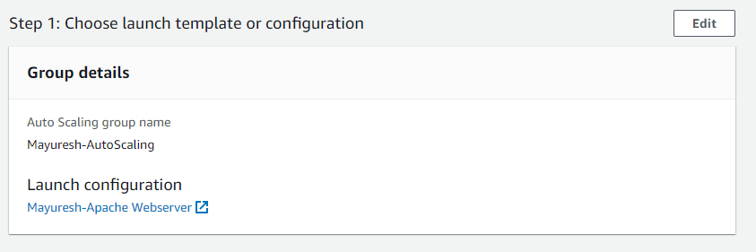

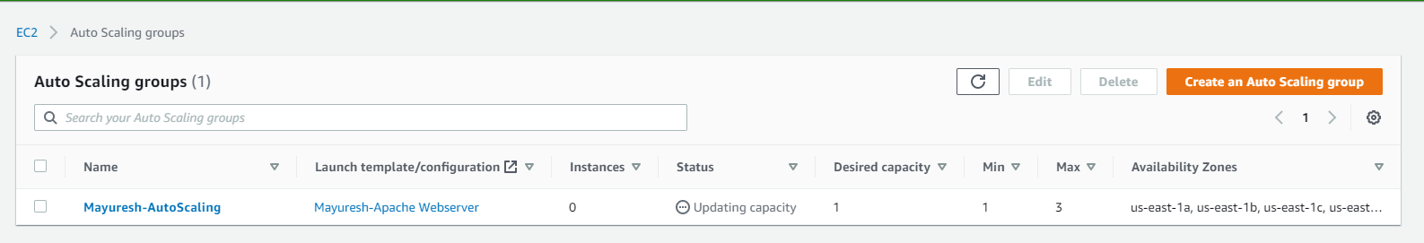

* Finally AutoScaling creates an instance which is seen alongside the Original Webserver

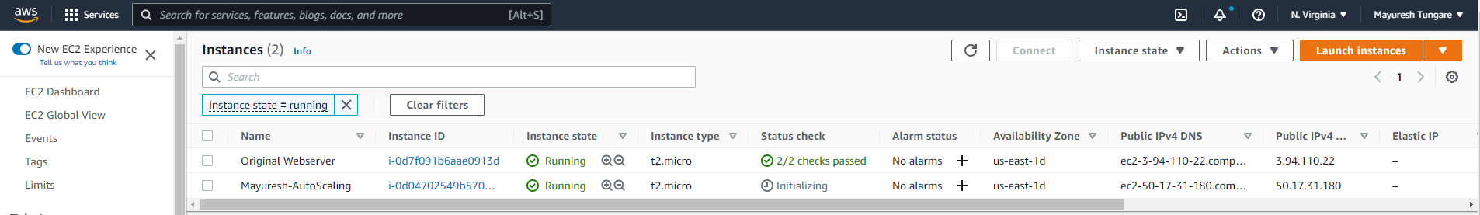

Assignment is thus complete.